**Ministry of Higher Education**



**Modern Academy**

**Computer Science and Management**

**Technology in Maadi**

**Computer Science Department**

**Agri Ai Solutions**

**C5**

**Prepared by:**

**Abdulrhman Moghazy**

**Abdulrhman Hussein**

**Ahmed Mohamed**

**Mohamed Sameh**

**Khaled Hassan**

**Supervised By:**

Project Supervisor: Supervisor Assistant:

Dr**. Lamiaa Hassan** Eng**. Alaa Abu Al-Ela**

**Egypt (2024-2025)**

**Acknowledgement**

We have made a lot of effort into this project. However, the completion of this project could not have been possible without the participation and assistance of a lot of individuals contributing to this project.

Firstly, we would like to express our gratitude towards our university “**Modern Academy**” and its board members for their professionalism, supervision, and support that helped us grow on our educational journey.

“**Prof Dr. Nabil Debes**” For the exceptional quality of education we have received that could not have been without his supervision which in return helped us prepare for our professional career.

“**Prof. Dr. Mahmoud Gadallah**” For his guidance and keenness on providing us with the best educational facilities along with the department staff that helped us so much throughout our academic years.

“**Dr. Lamiaa Hassan**” For her valuable guidance and support in completion of this project. And for always pushing us to do better. We are truly thankful to have been given the opportunity to learn from her and be inspired by her encouragement since day one.

Finally, special thanks to **“**Eng. **Alaa Abu Al-Ela** **”** for her help and effort through the year and for always guiding us with patience and care. All the help and support that we have received during the implementation project is very much appreciated and it is the reason we were finally able to present our idea and make it real, hoping it helps many people out there.

**Abstract**

In response to the growing challenges in the agricultural sector, *AgriAISolutions* aims to transform traditional farming by integrating smart technologies into a unified and efficient ecosystem. This graduation project introduces a comprehensive agricultural service platform that leverages the power of web and mobile applications, embedded systems, and artificial intelligence to support landowners, farmers, and agricultural consultants.

the system enables users to access a wide range of agricultural services, including land maintenance, purchasing tools and fertilizers, and requesting expert consultations. Through a dedicated mobile application, users can also diagnose plant diseases by capturing images, which are then analyzed using a trained AI model that offers accurate identification and treatment suggestions.

According to studies, nearly **30% of plants die due to diseases that are not detected and treated in early stages**, highlighting the critical importance of smart solutions like Agri AI to ensure timely interventions and reduce agricultural losses.

On the technical side, the project features an embedded system based on the ESP32-CAM and soil sensors to monitor plant health and soil salinity. The system automatically alerts landowners in case of abnormalities, allowing them to take immediate action to protect their crops.

Service providers—such as companies offering fertilizers, pesticides, or consultancy—can manage their offerings via the platform and efficiently reach a broader user base. Both individuals and providers benefit from a seamless user experience, real-time communication, and smart data management.

By combining AI-powered insights, IoT-based monitoring, and accessible digital services, *AgriAI Solutions* represents a significant step forward in the journey toward smart, sustainable agriculture. It aims to enhance productivity, reduce risks, and empower users with actionable data for a more resilient farming future.

**Table Of Contents:**

# **Chapter 1: Introduction**

1.1 Agri AI Solutions Platform ………………………………………………………………………. 9

  • Problem Definition…………………………………..……………………................................. 9

1.2 Solutions Approach…………………………………..………………………………………...… 10

1.3 Objectives of the Project………………………………….……….…………………………...… 11

1.4 Advantages………………………………….…………………….……………………………… 11

  1.4.1 Advantages for Farmers……………………….…………….……………………………. 12

  1.4.2 Advantages for Experts ……………..……………………….……….……………………13

1.4.3 Advantages for Companies ………………………………….…………………………….13

1.5 Main Entities in the System ………………………………………….……………………….…..14

  1.5.1 Application Function………………………………………….…………………………...15

  1.5.2 Main Work Tools and Technologies ………………………….…………………………...16

  1.5.3 Website Content……………………………………………….…………………………...17

  1.5.4 Artificial Intelligence Content………………………………….…………………….……20

  1.5.5 Artificial Intelligence Libraries………………………………….………………………...21

1.6 The Embedded System………………………………………………….….……………………..24

1.7 Mobile Application Development ……………………………………….………………….……27

# **Chapter 2: Software Life Cycle & Analysis**

2.1 Project Development Methodology (Phases) …….……………………………………………...30

  2.1.1 Software Development Method…………………………………………….…………….30

  2.1.2 Software Lifecycle Phases………………………………………………………………..31

2.2 Requirements ……………………………………………………………………...…………….33

  2.2.1 Requirements Analysis …………………………………………………………………..33

  2.2.2 System Requirements …………………………………………………………..………..33

  2.2.3 Software Requirements Specification ………………………………...…………………34

  2.2.4 Tools ……………………………………………………………………………………..36

2.3 System Design…………………………………………………..……..………………………...37

# **Chapter 3: Survey & Historical Data**

3.1 Historical Data ……………………...…………………………………………………………….39

  3.1.1 PlantVillage …………………………..………………………………………………........39

  3.1.2 Agrivi………………………….………………………………………………………...…40

3.2 Agricultural Sector Overview in Egypt…..……………………………………………………......41

3.3 Survey Results & Disease Impact Statistics……….………………………………………….......42

# **Chapter 4: Design**

4.1 Flow Chart Diagram …………………………………………………………………………….44

4.2 Entity Relationship Diagram (ERD) …………………………………………………………….45

4.3 Sequence Diagram ………………………………………………………………………………46

4.4 Use Case Diagram……………………………………………………………………………….47

4.5 The Relation Between Tables in Our Database …………………………………………………48

4.6 Tables Schema ………………………………………………………………………………......49

# **Chapter 5: System Implementation**

5.1 Design …………………………………………………………………………………………...51

  5.1.1 Farmer Dashboard ……………………………………………………………………….52

  5.1.2 Expert’s Dashboard ……………………………………………………………………...53

  5.1.3 Admin Dashboard ………………………………………………………………………..54

  5.1.4 Companies’ Dashboard …………………………………………………………………..55

5.1.5 Landing Page Design – Agri AI Homepage ……………………………………………. 56

5.1.6 Chat page ………………………………………………………………………….……..57

5.1.7 plant analysis Result design ……………………………………………………………..58

5.2 Artificial Intelligence ……………………………………………………………………………59

5.2.1 Feedback & Knowledge Assessment …………………………………………………….60

5.2.2 Advantages of Agri AI’s Smart System ………………………………………………….61

5.2.3 Building the AI Model for Agri AI Solutions ……………………………………………61

5.3 Model Training & Deployment Pipeline……………………………..…………………………62

# **Chapter 6: Conclusions & Future Work**

6.1 Conclusion ………………………………………………………………………………………..64

6.2 Future Work ……………………………………………………………………………………....65

**References** …………………………………………………………………………………....67

| **List Of Figures:** |  |
| --- | --- |
| Figure WEB-PHOTO | 17 |
| Figure Ai | 22 |
| Figure Ai (Libraries) | 23 |
| Figure Ai (Libraries) | 23 |
| Figure Software development | 30 |
| Figure Historical data | 39 |
| Figure Historical data | 40 |
| Figure Historical data | 42 |
| Figure Flow chart | 44 |
| Figure ERD | 45 |
| Figure Sequence diagram | 46 |
| Figure Use case diagram | 47 |
| Figure Relation between tables in our Database | 48 |
| Figure Tables Schema | 49 |
| Figure 5.1: Figma Frames Overview | 51 |
| Figure 5.2: Farmer Dashboard Design | 52 |
| Figure 5.3: Expert Dashboard Design | 53 |
| Figure 5.4: Admin Dashboard Design | 54 |
| Figure 5.5: Company Dashboard Design | 55 |
| Figure 5.6: Landing Page Design | 56 |
| Figure 5.7: Chat page Design | 57 |
| Figure 5.8: plant analysis Result design | 58 |

**Chapter 1**

**Introduction**

* 1. **Agri Ai Solutions Platform**

• Our project aims to revolutionize the agricultural industry with a smart, integrated platform called *Agri AI Solutions*. Designed as an upgrade from traditional agricultural services, our platform provides an intuitive and efficient experience for landowners, farmers, agricultural experts, and companies alike.

• **Farmers** can easily request services like land maintenance, purchase tools and fertilizers, and even get instant plant disease diagnoses using AI. Each farmer has a personalized dashboard that contains all the information about their farm's health, service requests, and AI-generated reports.

• **Agricultural Experts** can offer consultations, monitor farm conditions remotely, provide guidance on treatments, and upload content like recommendations for fertilizers or pest control. Each expert has a dedicated dashboard displaying farmer data, soil condition reports, and plant health analytics.

**• Companies** can list their products such as fertilizers, pesticides, and tools. They can receive service requests and orders from farmers and track their sales and interactions through a specialized company dashboard.

**Problem Definition**

• **Delayed Disease Detection:** Farmers struggle to identify plant diseases early, leading to crop loss. According to studies, 30% of plants die due to undiagnosed diseases.

• **Lack of Access to Expert Consultation:** Farmers in remote areas often cannot connect with agricultural experts easily.

• **Manual Service Management:** Managing service requests and agricultural tasks manually is inefficient and time-consuming.

• **Poor Communication:** There is a communication gap between farmers, experts, and service providers.

• **Limited Access to Agricultural Supplies:** Farmers often face difficulties in purchasing fertilizers, pesticides, and tools from trusted companies.

**1.2 Solutions Approach**

**AI-Powered Disease Diagnosis:** The platform enables farmers to capture high-quality images of their crops using integrated camera modules such as the ESP32-CAM. These images are analyzed using advanced AI models trained on a wide dataset of plant diseases. The system then provides accurate diagnoses along with personalized treatment recommendations, helping farmers take immediate and informed action to protect their crops and improve yield quality. **Real-time Monitoring:** Embedded systems equipped with environmental sensors continuously monitor critical soil and plant parameters such as moisture, temperature, and pH levels. This data is collected and transmitted in real time, allowing farmers to stay constantly informed about the health of their fields. Instant alerts are generated if any abnormal conditions are detected, enabling rapid response to prevent potential damage.

**Seamless Communication:** The platform fosters direct interaction between farmers, agricultural experts, and companies through features such as live chat, voice/video calls, and virtual consultation sessions. This integrated communication framework ensures quick access to professional advice and support, especially in remote or underserved areas.

**Personalized Dashboards:** Each user type—farmer, expert, or company—has access to a customized dashboard that displays relevant data and tools tailored to their needs. Farmers can track crop health, consultation history, and purchases; experts can manage diagnostics and recommendations; companies can view customer interactions and product performance.

**Marketplace Integration:** An integrated marketplace allows agricultural companies to list their products and services, such as fertilizers, seeds, pesticides, and equipment. Farmers can browse these offerings, read reviews, compare prices, and make purchases directly through the platform, simplifying procurement and enhancing transparency.

**1.3 Objectives Of the Project**

**Empower Farmers:** To provide an intelligent and accessible digital platform that equips farmers with AI-driven tools for plant disease detection, access to expert knowledge, and real-time field insights, enabling better decision-making and more efficient farm management.

**Facilitate Expert Services:** To enable agricultural experts to remotely offer their services, conduct virtual consultations, analyze plant conditions using submitted images and sensor data, and deliver timely, science-based recommendations to farmers in need.

**Support Companies:** To assist agricultural companies in reaching their target audience effectively by offering a dedicated space to promote their products and services, gather feedback, and establish lasting relationships with farmers and industry professionals.

**Enhance Communication:**  To build a robust, interactive communication network among all stakeholders—farmers, experts, and agribusinesses—ensuring seamless collaboration, faster problem resolution, and a more connected agricultural ecosystem.

**1.4 Advantages**

The platform offers **a wide range** of advantages that enhance productivity, communication, and service accessibility across the agricultural ecosystem:

• **Instant** **AI Diagnosis**: Enables fast and accurate detection of plant diseases through AI-powered image analysis, helping farmers take timely action to protect their crops.

• **Easy Access to Services**: Farmers can easily request services such as land maintenance, irrigation support, or expert consultations directly through the platform.

• **Personalized Farm Dashboard**: Offers a centralized view of farm metrics including soil health, salinity levels, crop conditions, and service history.

• **Enhanced Communication**: Engage with experts and suppliers through live chat and forums.

• **Reliable Marketplace**: Buy tools, fertilizers, and pesticides from trusted companies.

**1.4.1 Advantages for Farmers:**

Farmers benefit from a powerful set of features tailored to their specific needs and challenges:

* **Instant AI Diagnosis:** Capture images of affected crops and receive immediate AI-generated diagnoses and treatment plans to reduce crop losses.
* **Easy Access to Services:** Effortlessly request essential agricultural services, consult with experts, and purchase necessary supplies without leaving the farm.
* **Personalized Farm Dashboard:** Monitor key indicators such as plant health, soil moisture, and salinity, along with tracking ongoing service requests.
* **Enhanced Communication:** Connect with agronomists and suppliers through a user-friendly interface that supports live messaging and community engagement.
* **Reliable Marketplace:** Gain access to a vetted marketplace where farmers can compare products, read reviews, and make secure purchases from trusted vendors.

**1.4.2 Advantages For Experts:**

Agricultural experts benefit from tools and features that enhance their ability to support farmers remotely and efficiently:

* **AI-Assisted Diagnostics:** Utilize AI tools to assist in diagnosing plant diseases based on submitted images and environmental data, improving accuracy and decision-making.
* **Efficient Appointment Management:** Schedule, manage, and track virtual consultations and service requests with ease through a centralized system.
* **Remote Consultations:** Provide expert guidance through live chat, video calls, and report submissions, eliminating the need for on-site visits.
* **Build Professional Reputation:** Interact directly with farmers, share knowledge, and contribute to the community—enhancing credibility and visibility among users.

**1.4.3 Advantages for Companies:**

Agricultural companies gain a direct channel to engage with their target market and grow their business:

* **Product Marketing:** List and promote agricultural products such as seeds, fertilizers, pesticides, and equipment on a dedicated digital marketplace.
* **Direct Orders from Farmers:** Receive orders and inquiries directly from farmers, reducing reliance on third-party distributors and enhancing profit margins.
* **Customer Insights:** Access data on purchasing trends, product performance, and user feedback to better tailor offerings.
* **Brand Visibility:** Increase brand exposure among a relevant user base of farmers and experts through featured listings and reviews.
* **Trust Building:** Engage with the farming community by providing support, responding to inquiries, and ensuring product reliability—establishing long-term trust.

**1.5** **Main Entities in the System**

The platform includes several key entities, each playing a critical role in the ecosystem:

* **Farmer:**End-users who are landowners or agricultural workers. They use the platform to request services, submit plant images for AI-based diagnosis, purchase agricultural products, and monitor farm status via a dedicated dashboard.
* **Agricultural Expert:** Professionals who provide remote consultations, diagnose plant diseases with the assistance of AI tools, and offer tailored recommendations to farmers based on sensor data and visual analysis.
* **Company:**Agricultural input and service providers. These entities offer products such as fertilizers, pesticides, tools, and provide services like land preparation or irrigation. They interact directly with farmers through the platform.
* **Admin (Supervisor):** System administrator responsible for maintaining platform functionality. Duties include user management, company listing approvals, activity monitoring, and ensuring data security and system reliability.
* **AI Assistant:** An embedded smart assistant that supports experts and farmers by analyzing images, identifying diseases using machine learning models, and suggesting appropriate treatments. It also helps process sensor data for deeper insights.

**1.5.1 Application Function:**

Each entity has a defined set of functions within the application:

**Farmer:**

* Register and log in to the system.
* Upload plant images for automated disease diagnosis.
* Request services (e.g., land maintenance, irrigation) and place product orders.
* View crop health data through the personalized dashboard.

**Agricultural Expert:**

* Log in to manage consultations and farmer requests.
* Use AI-assisted tools to analyze submitted plant images.
* Generate diagnostic reports and communicate recommendations via live chat or scheduled consultations.

**Company:**

* Register on the platform to list services and sell products.
* Manage inventory, receive orders from farmers, and track delivery or service completion.

**Admin (Supervisor):**

* Oversee user accounts and verify the legitimacy of company profiles.
* Monitor system performance, user activity, and handle data moderation.
* Control platform content, including announcements and updates.

**AI Assistant:**

* Analyze plant images uploaded by users.
* Detect plant diseases based on trained machine learning models.
* Provide suggested treatment plans to both farmers and agricultural experts.

**1.5.2 Main Work** **Tools and Technologies:**

**Figma**

Used for the UI/UX design of both web and mobile platforms. Figma enabled the creation of interactive prototypes, consistent design systems, and efficient testing across different screen sizes.

**Key Features Utilized:**

* Components & Variants
* Auto Layout for responsive designs
* Interactive Prototypes (click-through demos)
* Shareable Design Systems for team collaboration
* Responsive Testing for multiple devices

**Visual Studio Code:** is a dual-licensed source-code editor made by Microsoft for Windows, Linux and macOS. In the Stack Overflow 2019 Developer Survey, Visual Studio Code was ranked the most popular developer environment tool, with 50.7% of 87,317 respondents reporting that they use it. Visual Studio Code is a source-code editor that can be used with a variety of programming languages, including Java, JavaScript, Go, Node.js, Python and C++.It is based on the Electron framework, which is used to develop Node.js Web applications that run on the Blink layout engine. Visual Studio Code employs the same editor component (codenamed “Monaco”) used in Azure DevOps (formerly called Visual Studio Online and Visual Studio Team Services).

**1.5.3 Website Content**:

**Front-End Technologies**

The front-end of the website is responsible for how information is presented to users. It interacts with the back-end to fetch data and display it dynamically within the user’s browser.

**HTML (Hyper Text Markup Language)**

HTML is the backbone of any web page, used to structure the content using tags. It defines the layout of text, images, and other elements, providing the basic structure for the user interface.

**Tailwind CSS**

Instead of traditional CSS, **Tailwind CSS** was used as a utility-first CSS framework to style the application. Tailwind allows developers to apply predefined utility classes directly in the markup, making the styling process more efficient and consistent without writing custom CSS files. This approach speeds up development and ensures design consistency across all components.

**JavaScript (JS)**

JavaScript is a lightweight, interpreted programming language that enables interactivity on web pages. It supports multiple paradigms, including object-oriented and functional programming, allowing for flexible development of user interactions and real-time behaviors.

**React.js**

React was used as the main front-end library for building user interfaces. It provides a component-based architecture, using JSX and a virtual DOM to enable fast, dynamic, and interactive web applications. React facilitated the development of features such as:

* **Dynamic dashboards** for farmers, experts, and companies
* **Interactive forms** for service requests
* **Real-time data updates** and product listings

This combination of **React** and **Tailwind CSS** resulted in a modern, responsive, and user-friendly front-end experience tailored for different user roles.

**Visual Assets – Freepik**

To improve the visual appearance and user engagement of the platform, **Freepik** was used as the primary source for illustrations and graphical assets.

**Freepik** provides a wide range of high-quality vector graphics, icons, and illustrations, which were utilized in the project to:

* Enhance UI screens with appealing visuals tailored to the agricultural domain.
* Support user understanding through explanatory images in onboarding, forms, and dashboards.
* Maintain a professional and modern design without the need for custom illustration work.

By leveraging Freepik’s rich asset library, the platform was able to achieve a visually engaging and user-friendly interface while maintaining development efficiency.

**Icon Library – Lucide React**

To implement clean, modern, and scalable icons across the application, **Lucide React** was used as the main icon library.

**Lucide** is an open-source icon toolkit based on the popular Feather icons, rebuilt with improved consistency and modern design. The **Lucide React** package made it easy to integrate SVG icons directly as React components, allowing for:

* Smooth integration with Tailwind CSS and React JSX structure.
* Lightweight and customizable icons for better performance.
* Consistent visual style throughout all user interfaces, including dashboards and action buttons.

**Backend Technologies**

The backend of **Agri AI Solutions** is responsible for managing business logic, handling service requests, interacting with the embedded system, processing AI-related tasks, and securely communicating with the database. It ensures smooth data flow between the front-end interface and backend services.

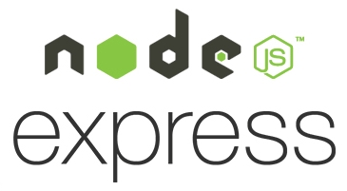**Node.js & Express.js**

The backend was built using **Node.js**, a powerful JavaScript runtime, along with **Express.js**, a minimal and flexible web application framework. This stack provided a fast and scalable foundation for building RESTful APIs and integrating different system components.

Key backend features implemented with Node.js & Express:

* Routing and handling RESTful API endpoints
* Managing user authentication and session handling
* Connecting with the MongoDB database
* Receiving data from the embedded system and AI modules
* Serving responses for the frontend in real-time

**RESTful APIs**

RESTful architecture enabled efficient and modular communication between system components, including:

* Submitting plant images and retrieving AI-based diagnoses
* Receiving real-time data from the **embedded system** (e.g., ESP32-CAM)
* Managing agricultural service requests and statuses
* Role-based authentication for farmers, experts, companies, and admins
* Handling product and order management features

**MongoDB** : a document-oriented NoSQL database, was chosen for its flexibility and ability to handle complex and varying data structures.

Main MongoDB use cases:

* User profile storage
* Service request and AI diagnosis logging
* Product listing and transaction data
* Real-time data from the embedded system

**1.5.4 Artificial Intelligence Content:**

The artificial intelligence (AI) component of the Agri AI Solutions platform was primarily implemented using **Python**, a powerful high-level programming language known for its simplicity and extensive ecosystem. Python supports rapid development of AI models through a wide range of mature libraries and frameworks.

**Python**

Python was chosen for its readability, strong community support, and a vast collection of AI and machine learning libraries. It significantly reduces development time by providing pre-built modules and tools for data manipulation, image processing, and model training. Its flexibility made it ideal for integrating computer vision algorithms and deep learning models into the platform.

**OpenCV**

**OpenCV** (Open Source Computer Vision Library) is a highly optimized library of real-time computer vision algorithms. It provides more than 2,500 state-of-the-art and classic algorithms that support tasks such as:

* Face detection and recognition
* Object identification
* Motion tracking
* Image filtering and enhancement

In Agri AI, OpenCV was used to process images submitted by users (e.g., plant images), preparing them for AI diagnosis through techniques like resizing, noise reduction, and color transformation.

**TensorFlow:** is an open-source machine learning framework developed by Google, widely used for building and training deep learning models. It supports a wide range of AI tasks, from image classification to natural language processing.

In the context of Agri AI, TensorFlow was utilized to:

* Train and deploy models for plant disease detection
* Perform classification based on image data submitted by farmers
* Enable scalable model inference and integration with the backend

TensorFlow’s robustness and scalability allowed for efficient training of convolutional neural networks (CNNs), which are well-suited for agricultural image analysis.

**1.5.5 AI Development Libraries and Frameworks:**

To implement the artificial intelligence components of **Agri AI Solutions**, a set of robust and well-established Python libraries and frameworks were used. These tools provided the necessary capabilities for model development, computer vision, numerical computation, and API communication. The following are the core libraries and frameworks utilized:

**1. TensorFlow**

**Overview**:  
TensorFlow is an open-source machine learning framework developed by Google. It is widely used for building and deploying deep learning models and supports a broad range of AI applications, from image classification to natural language processing.

**Key Features**:

* **Flexible Architecture**: Supports computation across CPUs, GPUs, and TPUs.
* **High-Level APIs**: Integrated with Keras for rapid prototyping and training.
* **TensorFlow Lite**: Designed for mobile and embedded AI applications.
* **TensorFlow Serving**: Simplifies production-grade model deployment.
* **Ecosystem Tools**: Includes TensorBoard for training visualization and TensorFlow Hub for reusable models.
* **Cross-Platform Support**: Compatible with Windows, macOS, Linux, and major cloud environments.



**2. OpenCV**

**Overview**:  
OpenCV (Open Source Computer Vision Library) is a powerful open-source library designed for real-time computer vision and image processing applications.

**Key Features**:

* **Image and Video Processing**: Includes tools for filtering, transformations, and feature extraction.
* **Real-Time Performance**: Highly optimized with C++ core and Python bindings.
* **Machine Learning Support**: Implements algorithms like SVM, decision trees, and DNNs.
* **Camera Calibration and 3D Reconstruction**: Supports stereo vision and depth estimation.
* **Cross-Platform**: Runs on desktop and mobile platforms including Windows, Linux, macOS, iOS, and Android.
* **Comprehensive Modules**: Offers tools for facial recognition, object tracking, and AR development.

**3. NumPy**

**Overview**:  
NumPy is the foundational library for numerical computing in Python. It provides efficient data structures and functions for handling large datasets and performing complex mathematical operations.

**Key Features**:

* **N-Dimensional Arrays**: High-performance array manipulation using ndarray.
* **Mathematical Functions**: Built-in support for linear algebra, statistics, and FFTs.
* **Broadcasting**: Allows vectorized operations on arrays with different shapes.
* **Integration**: Works seamlessly with SciPy, Pandas, and TensorFlow.
* **Performance**: Backed by C for fast execution and memory efficiency.
* **Random Number Generation**: Useful for simulations and probabilistic models.



**4. FastAPI**

**Overview**:  
FastAPI is a modern Python web framework designed for building fast and scalable APIs using asynchronous programming and Python type hints.

**Key Features**:

* **High Performance**: Comparable to Node.js and Go thanks to async capabilities (via Starlette and Pydantic).
* **Auto Documentation**: Generates interactive API documentation (Swagger UI, ReDoc) directly from code.
* **Type Hinting**: Ensures input/output validation and type safety.
* **Dependency Injection**: Simplifies external service management (e.g., databases, auth).
* **Scalability**: Supports thousands of concurrent requests efficiently.
* **Testing Support**: Built-in tools for unit testing and integration testing.

**1.6 The Embedded System**

**Role of the Embedded System in the Project**

The embedded system plays a crucial role in the **Agri AI Solutions** platform by acting as the physical interface between the agricultural environment and the digital ecosystem. It is responsible for real-time data acquisition, communication with the AI model, and delivering timely feedback to users. The system is based on the **ESP32-CAM** module, which integrates a microcontroller with a built-in camera and wireless communication capabilities.

**1. Image Capture for Plant Analysis**

The ESP32-CAM is used to capture high-resolution images of crops directly from the field. These images are then transmitted to the AI module for analysis, enabling early detection of plant diseases through computer vision techniques. This automation reduces the need for manual monitoring and improves diagnostic accuracy.

**2. Alert Generation and Notifications**

In the event that the AI model identifies a potential issue—such as disease symptoms, nutrient deficiencies, or other anomalies—the embedded system facilitates immediate alert generation. These alerts are sent to farmers via the mobile application or the platform’s central notification system, ensuring prompt response and intervention.

**3. Data Communication with the AI Model**

The embedded system transmits environmental and visual data to the cloud-based AI engine for processing. Based on the model’s output, it relays actionable insights back to the farmers, such as irrigation recommendations, soil treatment suggestions, or pest control measures. This closed-loop interaction enhances decision-making and optimizes farm productivity.

**Libraries and Tools Used in the Embedded System**

The embedded system in the **Agri AI Solutions** project was developed using a combination of hardware and software tools that facilitated image capture, data transmission, and communication with the AI platform. The key libraries and tools employed include:

**1. Arduino IDE**

The Arduino Integrated Development Environment (IDE) was used to program the embedded system. Renowned for its user-friendly interface and extensive library support, Arduino IDE is widely adopted for embedded system development, enabling rapid prototyping and deployment.

**2. ESP32-CAM**

The ESP32-CAM is a compact development board equipped with a built-in camera and Wi-Fi capabilities. It was utilized to capture high-quality images of plants in the field and transmit these images wirelessly to the backend server for AI-based analysis.

**3. ESP32 Wi-Fi Library**

This library enables wireless communication functionalities on the ESP32 microcontroller. It allows the embedded device to connect to Wi-Fi networks, facilitating data transfer from sensors and image data to cloud servers or the mobile application seamlessly.

**4. MQTT Library**

MQTT (Message Queuing Telemetry Transport) is a lightweight publish-subscribe messaging protocol widely used in embedded and IoT systems. It was integrated to enable efficient, real-time communication between the embedded devices and the central server, ensuring timely delivery of alerts and sensor data.

**Advantages Provided by the Embedded System**

* **Operational Independence**:

The embedded system functions autonomously, performing local data collection and preliminary processing, which minimizes dependency on continuous internet connectivity.

* **Real-Time Responsiveness**:

Its ability to process and transmit data in real-time allows the system to provide immediate feedback and recommendations to farmers.

* **Seamless Integration**: The system can be integrated with other smart agricultural solutions, such as automated irrigation controllers and mobile applications, to form a comprehensive ecosystem.
* **Scalability and Flexibility**: Designed with extensibility in mind, the embedded system can be expanded with additional sensors and functionalities to cater to diverse agricultural needs.

**1.7** **Mobile Application Development**

**Mobile Application Development Using React Native**

The mobile application for the **Agri AI Solutions** platform was developed using **React Native**, an open-source framework created by Facebook that enables building cross-platform mobile apps using JavaScript and React. React Native allows for the development of native-like mobile experiences with a single codebase, significantly reducing development time and effort while maintaining high performance and native UI behavior.

**Core Features and Benefits of Using React Native**

* **Cross-Platform Compatibility:** React Native allows simultaneous development for both Android and iOS platforms, ensuring a consistent user experience across devices and minimizing platform-specific code.
* **Component-Based Architecture:**

Leveraging React’s component model, the app’s UI is modular, reusable, and easy to maintain. Components such as buttons, forms, and lists are built once and reused throughout the app, enhancing development efficiency.

* **Hot Reloading:** Developers benefit from React Native’s hot reloading feature, which speeds up development by instantly reflecting code changes without needing to recompile the entire app.

**Key Tools and Libraries Used**

* **React Navigation:** Used to implement smooth and intuitive navigation flows within the app. The app includes stack navigators for moving between screens such as the Camera screen, Diagnosis Results, and Advice pages. React Navigation supports deep linking, allowing users to open specific parts of the app directly via URLs or notifications.
* **State Management:** Global state management is achieved using **Redux** or the React **Context API** combined with hooks like useReducer and useContext. This architecture allows the app to efficiently handle asynchronous data updates such as AI diagnosis results, real-time sensor statuses, and user preferences without unnecessary re-renders.
* **Networking and API Calls:** The app communicates with backend AI services through HTTP requests, primarily using **Axios** for promise-based, easy-to-handle API calls. This includes uploading plant images (converted to multipart/form-data) and receiving JSON responses containing disease classification, severity levels, and recommended actions.
* **Image Capture and Handling:** Integration of **react-native-image-picker** and **react-native-camera** allows users to capture plant images via their device’s camera or select existing photos from the gallery. This flexibility facilitates seamless user interaction and accurate image collection needed for disease detection.
* **Push Notifications:** Using **Firebase Cloud Messaging (FCM)**, the app delivers timely notifications and alerts about crop health, irrigation advice, or system updates directly to users’ devices, enhancing engagement and responsiveness.
* **Cloud Integration:** The app leverages **Firebase Storage** to securely store user-uploaded plant images and **Cloud Firestore** to maintain a structured, scalable database of diagnosis results, historical data, and user feedback. This integration supports real-time data syncing and offline capabilities, ensuring a reliable user experience even with intermittent connectivity.

**AI Model API Integration**

* The mobile app sends captured images to a cloud-hosted AI backend via secure API endpoints.
* Images are processed in the backend using deep learning models to classify plant diseases and assess severity.
* The AI responds with detailed diagnosis results and actionable recommendations, which are displayed in the app’s user interface.
* This seamless communication empowers farmers to receive accurate, data-driven advice on crop health management directly on their smartphones.

**Chapter 2**

**Software Life Cycle & Analysis**

**2.1 Project Development Methodology (Phases)**

The characteristics of the agile methodology in software development helps to maximize productivity as the project is divided into short iterations.

**2.1.1 Software Development Method:**

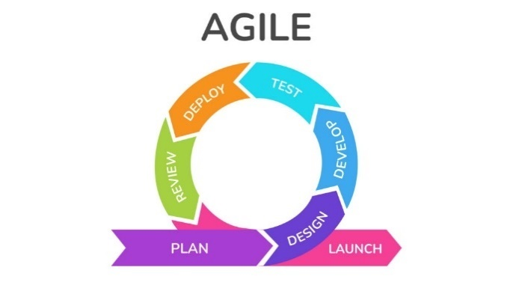The systems development life cycle (SDLC), or software development process in systems engineering, information systems and software engineering, is a process of creating or altering information systems, and the models and methodologies that people use to develop these systems. It consists of a set of steps or phases in which each phase of the SDLC uses the results of the previous one.

Agile software development refers to a group of software development methodologies based on iterative development, where requirements and solutions evolve through collaboration between self-organizing cross-functional teams. Agile methods or Agile processes generally promote a disciplined project management process that encourages frequent inspection and adaptation, a leadership philosophy that encourages teamwork, self-organization and accountability, a set of engineering best practices intended to allow for rapid delivery of high- quality software, and a business approach that aligns development with customer needs and company goals. Agile development refers to any development process that is aligned with the concepts of the Agile Manifesto.

**2.1.2 Software Lifecycle Phases:**

The agile lifecycle is a structured series of stages that a product goes through. It consists of six phases

Requirements collection

Design

Coding

Testing

Implementation And Maintenance

review

**Requirements Phase:** Stakeholders conduct an overall project assessment to determine the time and resources required for the development process. At the same stage, the owner assesses the risks and prioritizes the various functions depending on their business value.

**Design Phase:** The software owner meets with the software development team and introduces them to the requirements outlined in the first step. The group then discusses the sequence for introducing functions and identifies the essential tools – the programming language, syntax libraries, and basic frameworks. At the same stage, software development teams can prototype the expected user interface.

**Coding Phase:** After agreeing on the plan with the customer, the team develops the product itself. The product is delivered in stages, in separate sprints, each designed to improve the current version of the product. The initial release is likely to undergo many changes to provide improved functionality and new features.

**Testing Phase:**

At this point, the product becomes available to consumers, so the team must conduct a series of tests to ensure that the software is fully functional. If potential bugs or flaws are found, the developers will fix them immediately. At this stage, they also collected consumer feedback.

**Implementation And Maintenance Phase:**

The software is now fully deployed and available to customers. This action puts him in the maintenance phase. During this phase, the software development team provides ongoing support to keep the system running smoothly and fix any new bugs. Over time, further iterations are possible to update an existing product or add other functionality.

**Review Phase:**

That is the last stage of the Agile development cycle. After completing all the previous stages of development, the development team presents to the owner the result achieved in meeting the requirements. After that, the Agile software development phases start over – either with a new iteration or moving to the next stage and scaling Agile.

**2.2 Requirements**

**2.2.1 Requirements Analysis**

The first step in developing a reliable software system is to gather and analyze its requirements. Although users may believe they understand what the system should do, identifying incomplete, ambiguous, or conflicting requirements requires experience in software engineering. Therefore, requirements engineering is essential to ensure a shared understanding between stakeholders and developers before the system design begins.

**2.2.2 System Requirements**

**Software Requirements:**

* **Operating System:** PCs running Windows 7 or higher are required. However, higher performance specifications are recommended for running development tools such as Android Studio or web applications smoothly.
* **Database:** The system uses **MongoDB**, a NoSQL database, for storing user data, service requests, analysis results, and other relevant application data.
* **UI/UX Design:** **Figma** was used to design the interface and prototype for both the web and mobile applications.
* **Web Development Stack:**
  + Frontend: React.js, Tailwindcss, JavaScript
  + Backend: Node.js (with Express framework)
* **Mobile Development:** The mobile application was developed using **React Native**. React Native enables cross-platform development for Android and iOS using a single codebase written in JavaScript.
* **AI & Image Processing:**
  + **TensorFlow** – for building and deploying deep learning models
  + **OpenCV** – for image capture and real-time visual analysis
  + **NumPy** – for scientific computing and matrix operations
  + **Fast API** – to expose AI services via high-performance RESTful

**2.2.3 Software Requirements Specification**

**Functional Requirements**

* **System Administrator:**
  + Sign in
  + View all user accounts and dashboards
* **Agricultural Experts:**
  + Sign in
  + Respond to consultation requests
  + Monitor farmer history and progress
  + Use the AI assistant to generate disease diagnoses
  + View personal performance analytics
* **Agricultural Companies:**
  + Sign in
  + Offer services (fertilizers, pesticides, machinery, consultations)
  + Manage customer bookings and product listings
  + Monitor service performance and customer feedback
* **Farmers :**
  + Register and log in
  + Upload plant or soil images for AI analysis
  + View diagnosis and receive agricultural advice
  + Book services from companies or consult experts
  + Track history and health status of crops

**Non-Functional Requirements**

* **Usability:**  
  The system provides an intuitive and responsive user interface that is easy to navigate for all user types.
* **Availability:**  
  The system is available 24/7 throughout the semester for continuous monitoring and interaction.
* **Supportability:**  
  The system uses scalable and well-documented tools and frameworks including:
  + MongoDB for database
  + Node.js and ReactJS for web
  + React Native for mobile
  + TensorFlow and OpenCV for AI services

**System Users:**

1. **Administrator**
2. **Agricultural Experts**
3. **Farmers**
4. **Companies**

**2.2.4 Tools**

| **Purpose** | **Tools & Technologies** |
| --- | --- |
| UI/UX Design | Figma |
| Web Development (Frontend) | Tailwind CSS, JavaScript, React.js (using Visual Studio Code) |
| Web Development (Backend) | Node.js, Express |
| Mobile Application | React Native |
| Database | MongoDB |
| AI/ML Processing | TensorFlow, NumPy, OpenCV, Fast API |
| API Testing | Postman |
| Algorithms | Swarm Optimization (used in future versions for parameter tuning or decision support) |

**2.3 System Design**

System design focuses on defining the overall architecture and interaction of components in the system. It serves as a blueprint for developers and ensures all functional and non-functional requirements are addressed through structured planning.

**Design Phases:**

**Logical Design:**

Focuses on identifying the core modules, their responsibilities, and how they communicate. This includes components like user authentication, AI diagnosis, service management, and database interaction.

**Physical Design:**

Represents how the system will be implemented in practice. It includes diagrams like use-case diagrams, class diagrams, and data flow diagrams (DFD) to visualize user interactions and data movement.

**Database Design:**

Involves structuring MongoDB collections for users, service requests, reports, and AI results. The schema is flexible and designed for performance and scalability.

**Chapter 3**

**Survey & Historical data**

**3.1 Historical Context and Market Analysis**

**Review of Existing Platforms**

To develop a digital solution that truly addresses the needs of the agricultural sector, we conducted a thorough analysis of existing platforms offering similar services in plant diagnostics, agricultural support, and education. This helped us identify valuable features to adopt and common weaknesses to avoid in our own system.

**3.1.1 PlantVillage:**

• **Overview**: PlantVillage is a platform that uses AI to diagnose plant diseases through uploaded images. It has proven especially effective in developing countries.

• **Strengths**: Accurate disease detection results powered by machine learning.

• **Weaknesses**: Complex user interface and lack of Arabic language support, making it less accessible to Egyptian farmers.

• **Our Approach**: We adopted the AI-based diagnosis concept but focused on creating a more user-friendly and localized experience, including full Arabic support and simplified navigation.

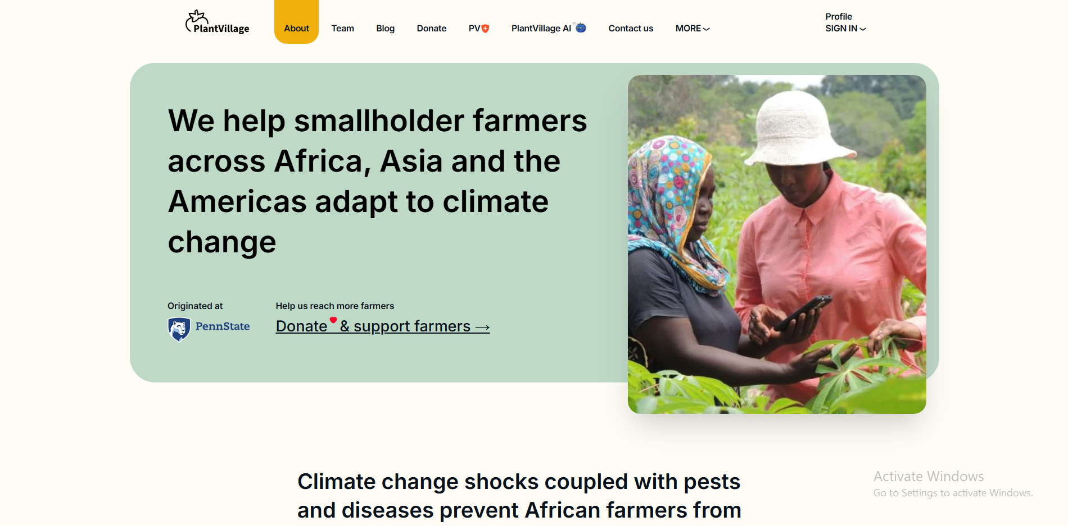

**3.1.2 Agrivi:**

* **Overview**: Agrivi offers a full farm management system, including crop tracking, cost monitoring, and data analytics.
* **Strengths**: Comprehensive tools for large-scale agricultural operations.
* **Weaknesses**: Primarily designed for commercial agribusinesses; too complex and expensive for smallholder farmers.
* **Our Approach**: We prioritized simplicity and accessibility, designing a lightweight platform that caters to small farmers, enabling them to book services and receive tailored agricultural support easily.

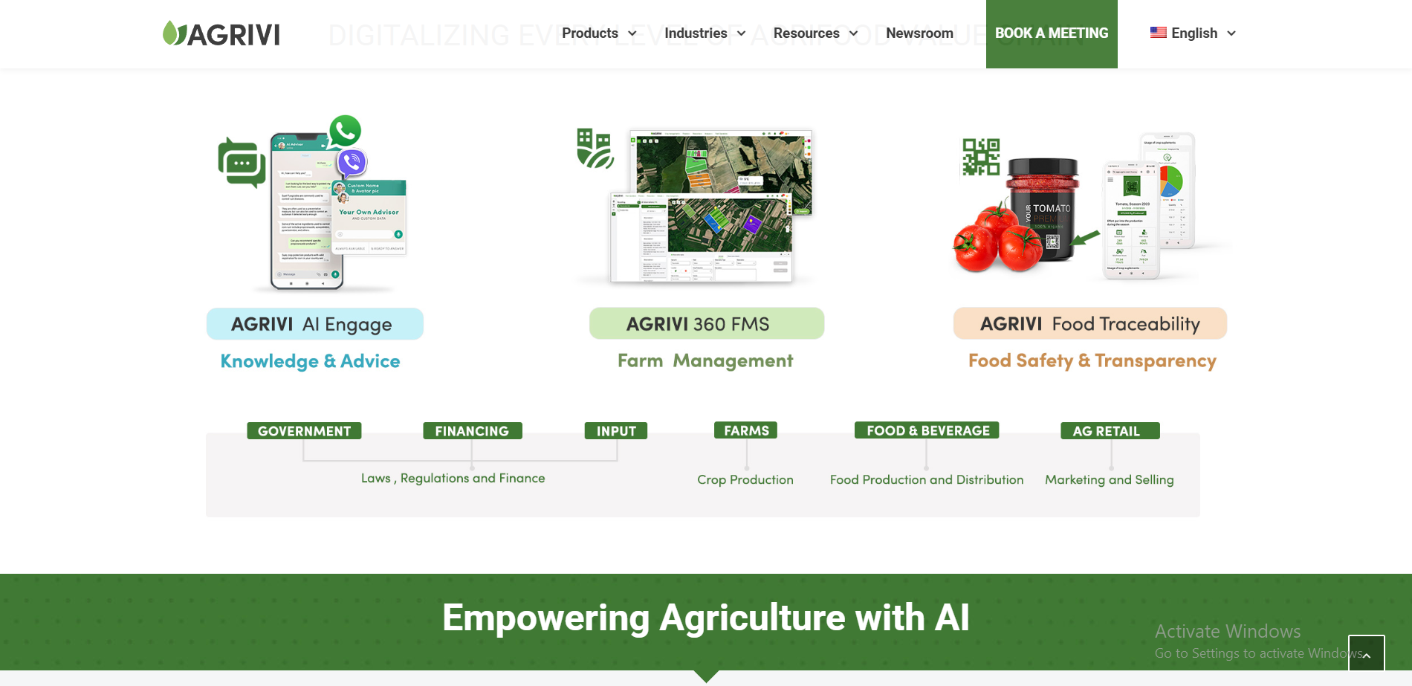

**3.2 Agricultural Sector in Egypt**

**Challenges & Opportunities**

Agriculture is one of the most vital sectors in Egypt’s economy. The following statistics and insights illustrate their importance:

* **Contribution to GDP**:

Approximately **14.5%** of Egypt’s GDP comes from agriculture, according to CAPMAS (Central Agency for Public Mobilization and Statistics).

* **Employment**:

Over **28%** of the Egyptian workforce is employed in agriculture.

* **Key Challenges**:
  + Limited access to modern farming technologies for small-scale farmers.
  + Lack of immediate and reliable agricultural consultations in rural areas.
  + Widespread crop diseases such as powdery mildew, blight, and wilting that significantly reduce yields.
  + Weak soil and crop monitoring infrastructure, with few early-detection digital solutions available

**How Our Project (Agri AI Solutions) Addresses These Challenges**

* Provides AI-powered plant disease diagnosis through image analysis.
* Enables service booking with agricultural engineers and verified companies.
* Supports real-time field monitoring using affordable embedded systems (e.g., ESP32-CAM).
* Offers a simple, Arabic-language mobile interface designed specifically for smallholder farmers.
* These features ensure that our system is not only technically innovative but also socially impactful and economically relevant.

**3.3 Survey Results & Disease Impact Statistics**

**Estimated Annual Crop Losses Due to Plant Diseases**

While there is no single global percentage, multiple studies estimate substantial agricultural losses due to plant diseases:

* According to the **Food and Agriculture Organization (FAO)**, up to **40%** of food crops are lost annually due to pests and plant diseases combined.
* Losses specifically from plant diseases are estimated at around:
  + **10%** in developed agricultural systems.
  + **15–20%** in less advanced agricultural systems.
* Additional losses during **post-harvest storage** can reach **25–30%**.
* Field studies also suggest an **annual disease infection rate** of **12–15%** in many regions.

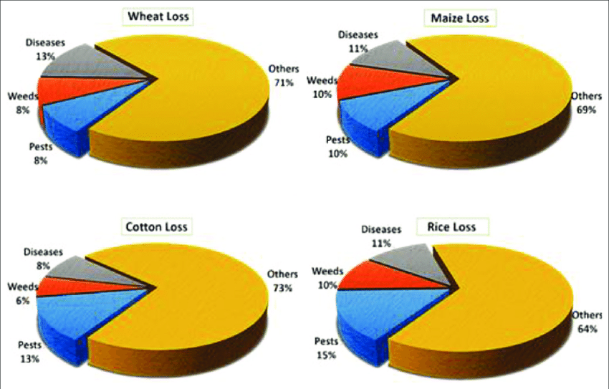

**Chapter 4**

**Design**

**4.1 Flowchart Diagram**

A **flowchart** is a graphical representation of a process, illustrating its steps using standardized symbols such as rectangles, diamonds, and arrows to indicate the flow of execution. This visual tool is essential in analyzing, designing, documenting, and managing workflows and programs.

Flowcharts enhance understanding by simplifying complex processes into visual sequences, making it easier to identify logical errors, bottlenecks, or opportunities for optimization. In this project, the flowchart is used to represent the user journey and operational logic of the agricultural support system.

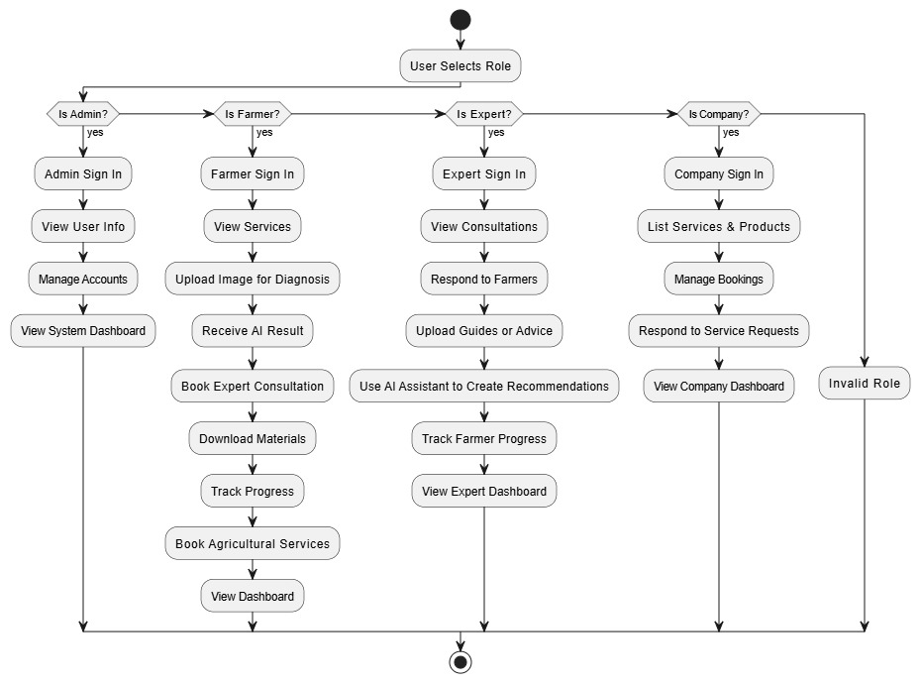

**4.2 Entity Relationship Diagram (ERD)**

The **Entity Relationship Diagram (ERD)** is a crucial component of the database design process. It visually maps out the entities (e.g., users, requests, services) within the system and the relationships between them.

ERDs help translate conceptual models into relational schemas, which then form the foundation of the actual database structure. This ensures the consistency, integrity, and clarity of the data model. The ERD was developed during the planning phase to define how the system components interact within the database.

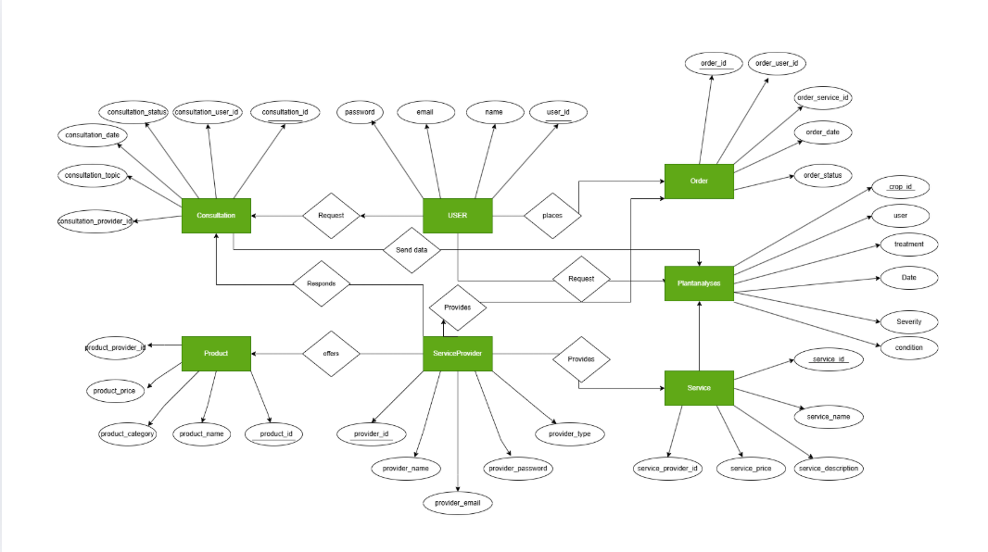

**4.3 Sequence Diagram**

A **sequence diagram** is a type of interaction diagram in Unified Modeling Language (UML) that shows how objects interact in a given scenario of a use case. It emphasizes the time order of messages exchanged between system components.

This diagram helps developers and stakeholders understand the real-time interaction between system elements, such as how a user sends a plant image and receives AI-based feedback. Sequence diagrams were used in this project to detail communication flows between users, the mobile app, the server, and the AI engine.

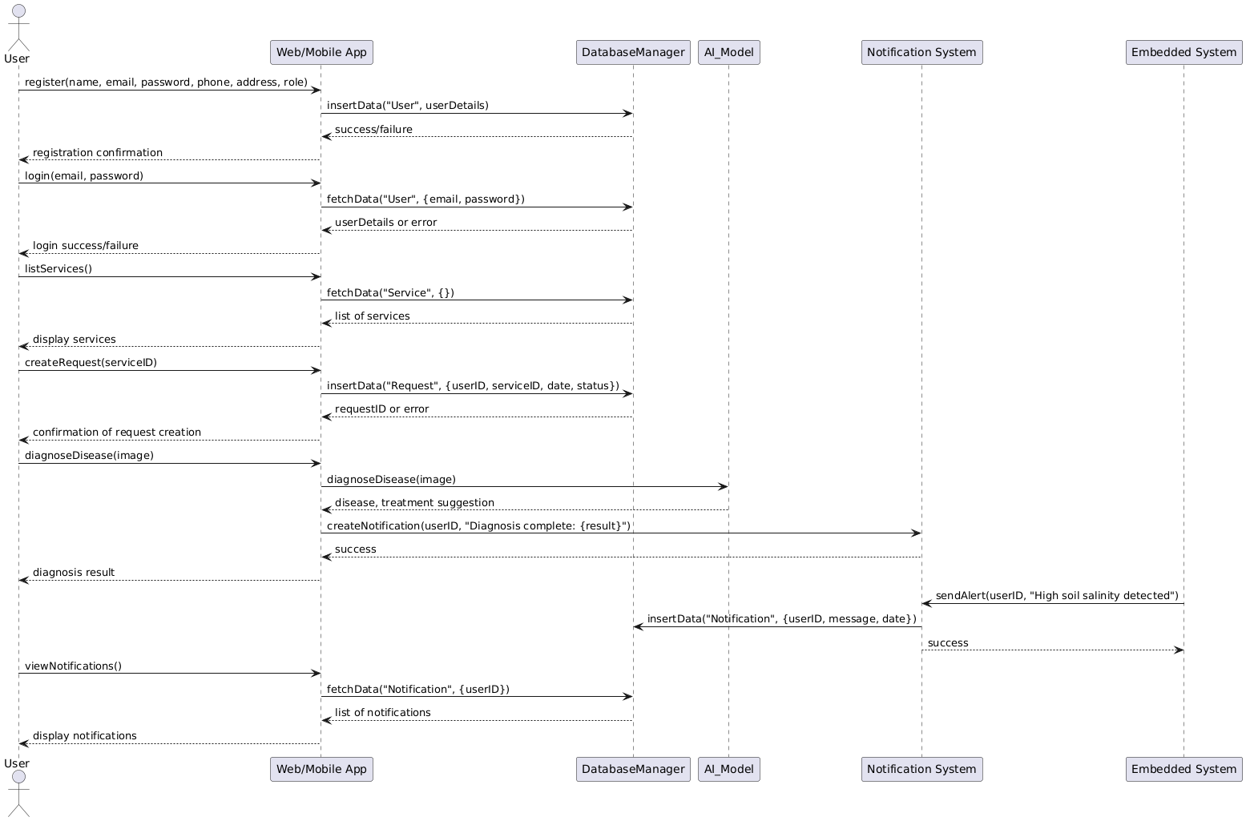

**4.4 Use Case Diagram**

**use case diagram** captures the functional requirements of a system from the end user’s perspective. It outlines the interactions between the users (actors) and the system functionalities (use cases) without detailing the internal workings.

This diagram helps visualize how different types of users (e.g., farmers, experts, companies, admins) interact with the system. It serves as a foundation for understanding user needs and system behavior, which is crucial during both development and testing phases.

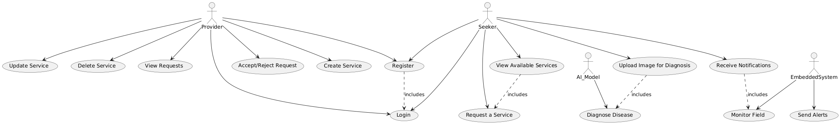

**4.5 Database Table Relationships**

The relationships between database tables are structured using a **database schema**. This scheme defines how data is logically organized and interrelated across multiple entities in the system.

The schema diagram outlines primary keys, foreign keys, and the types of relationships (one-to-many, many-to-many) between entities. This relational model ensures data consistency, supports complex queries, and facilitates scalable data storage for users, plant diagnoses, service bookings, and AI results.

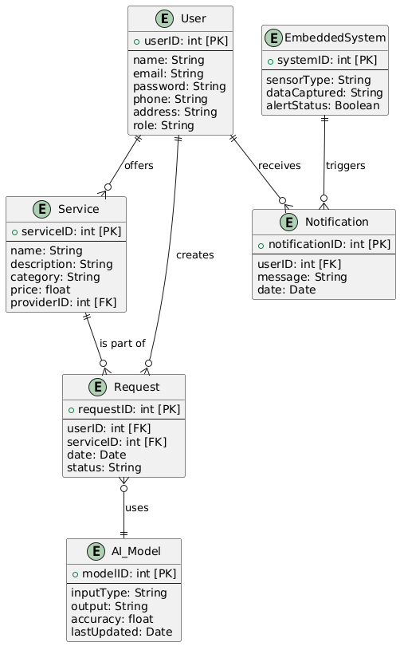

**4.6 Tables Schema**

The **table schema** section presents detailed information about each table in the database, including:

* Table name
* Fields/columns and their data types
* Primary and foreign keys
* Constraints and relationships

This structure is vital for understanding how data is stored, retrieved, and manipulated within the system. It also aids developers during integration and debugging phases, ensuring a robust and efficient backend architecture.

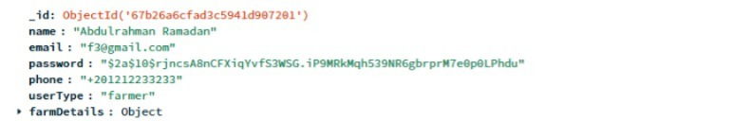

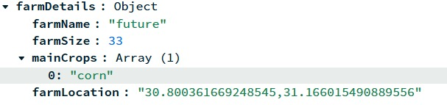

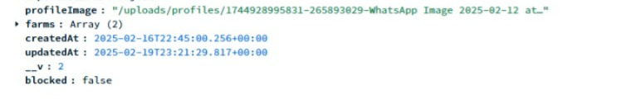

**Chapter 5**

**System Implementation**

**5.1 Overview of Design Process**

To build a user-friendly and functional platform, we used Figma to design the web interfaces. A total of 50 frames were created, including animated transitions and interactive prototypes that simulate user behavior across different roles and dashboards.

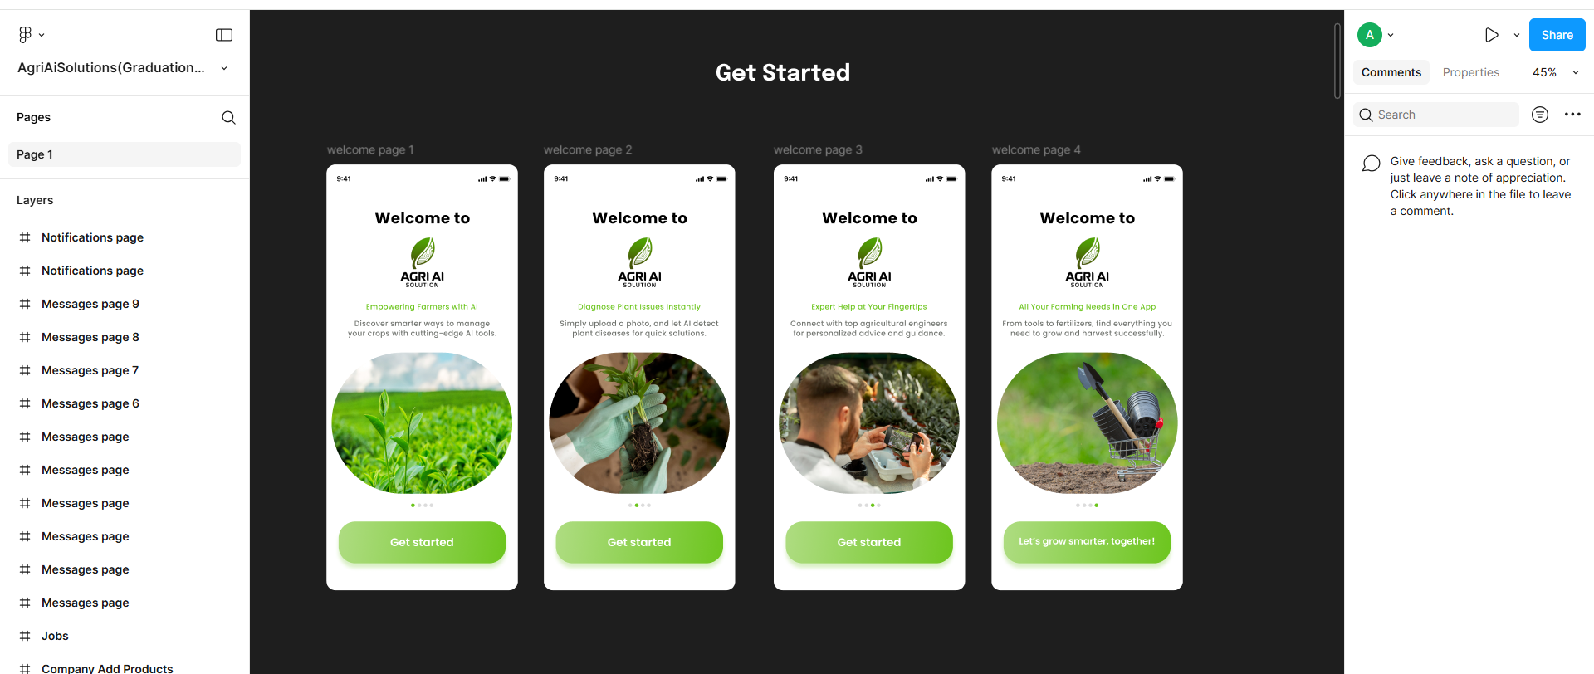

**Figure 5.1: Figma Frames Overview**

**5.1.1 Farmer Dashboard**

The **Farmer Dashboard** is designed to allow farmers to:

* Monitor their crops and farm health
* Access market features (e.g., supplies, tools)
* Request consultations from agricultural experts

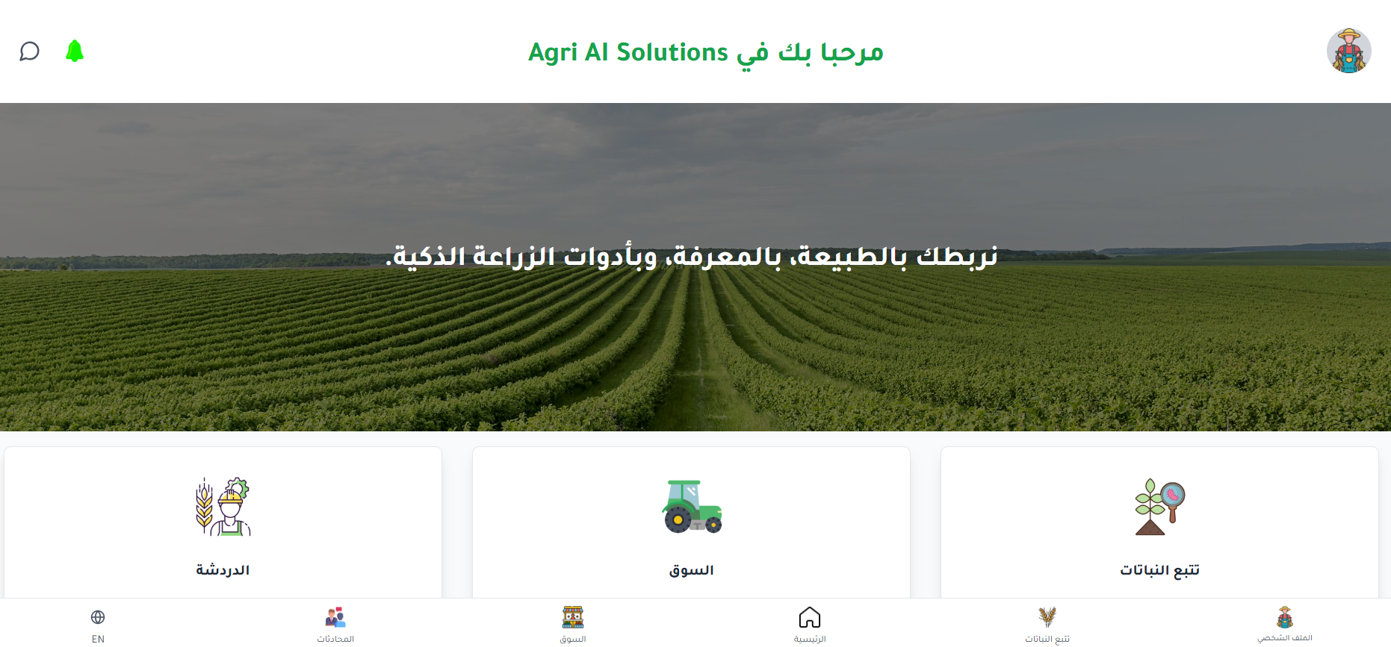

**Figure 5.2: Farmer Dashboard Design**

**5.1.2 Expert Dashboard**

The **Expert Dashboard** enables agricultural specialists to:

* View incoming consultation requests
* Respond with recommendations, diagnoses, and follow-up support

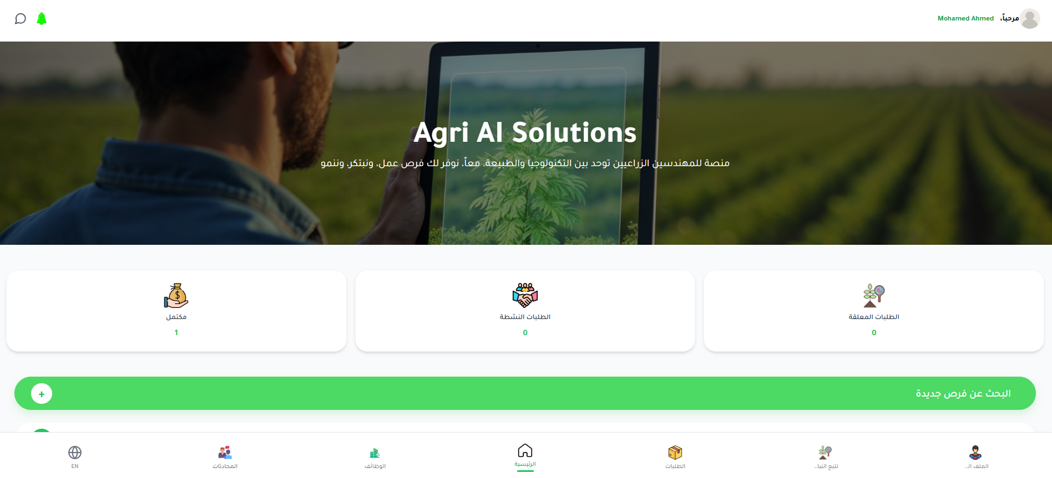

**Figure 5.3: Expert Dashboard Design**

**5.1.3 Admin Dashboard**

The **Admin Dashboard** is used by system supervisors to:

* Oversee platform activity
* Manage users, companies, and data integrity
* Approve or reject profiles

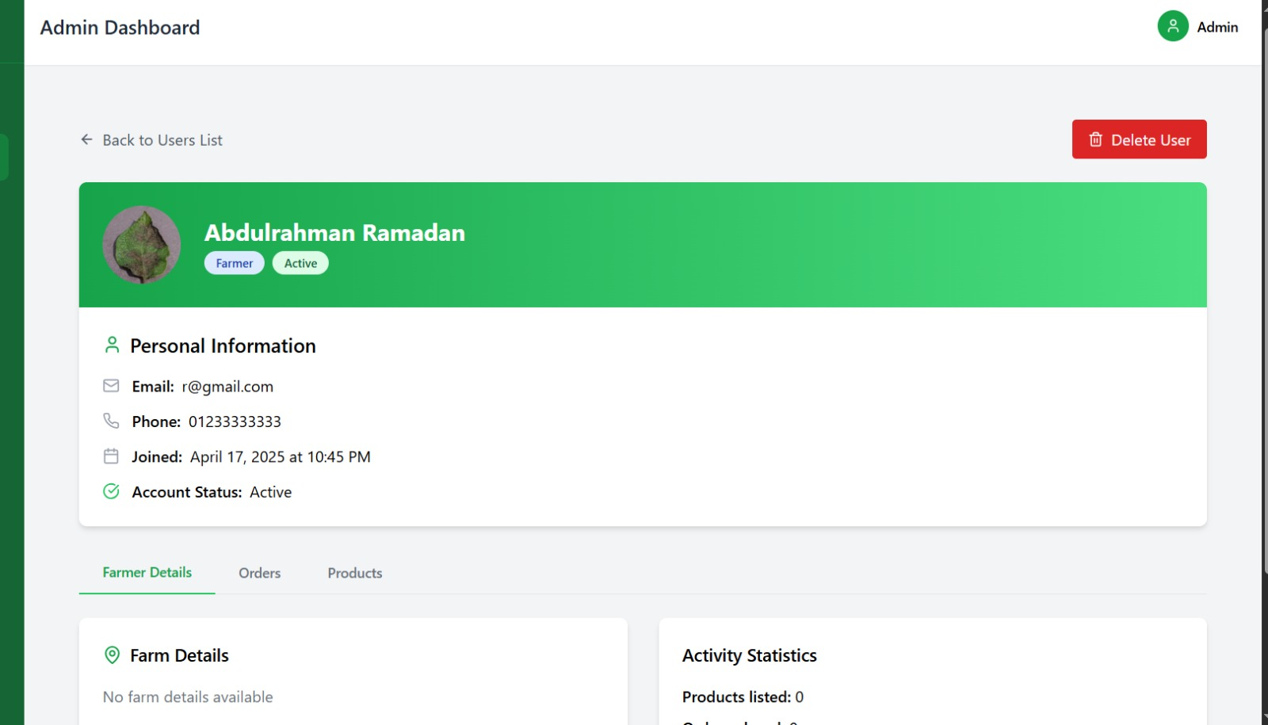

**Figure 5.4: Admin Dashboard Design**

**5.1.4 Company Dashboard**

The **Company Dashboard** allows agricultural service providers to:

* Manage product listings (e.g., fertilizers, tools, pesticides)

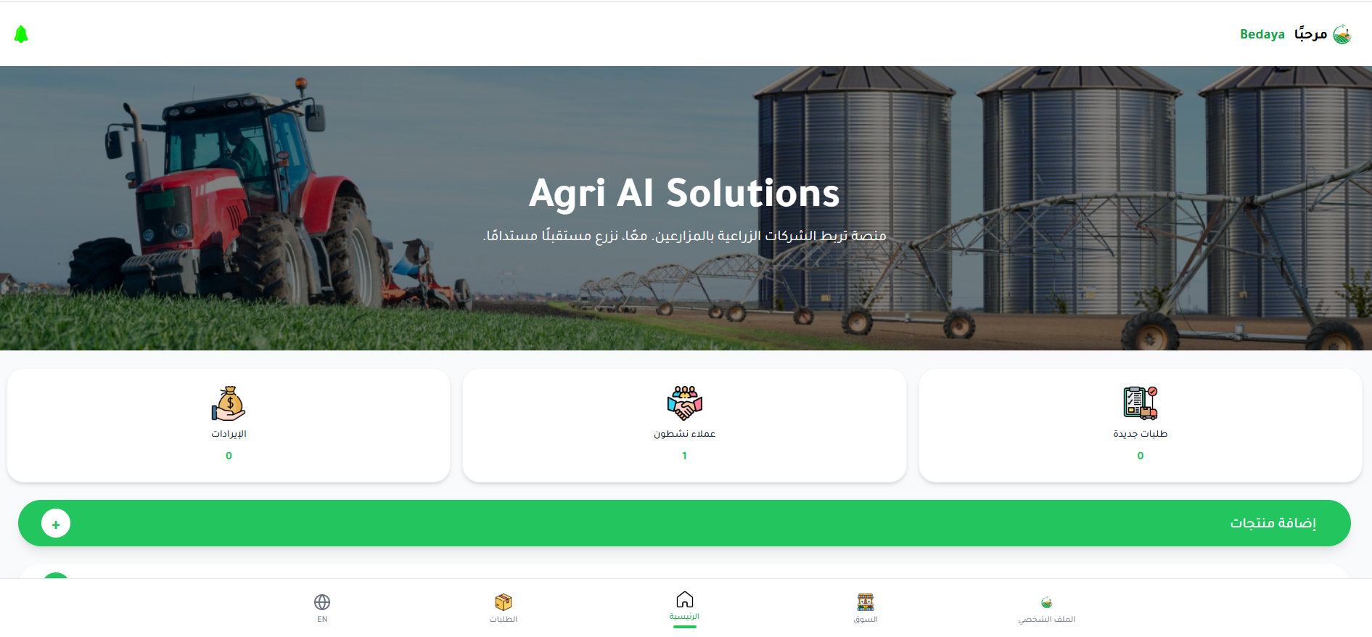

**Figure 5.5: Company Dashboard Design**

**5.1.5** **Landing Page Design – Agri AI Homepage**

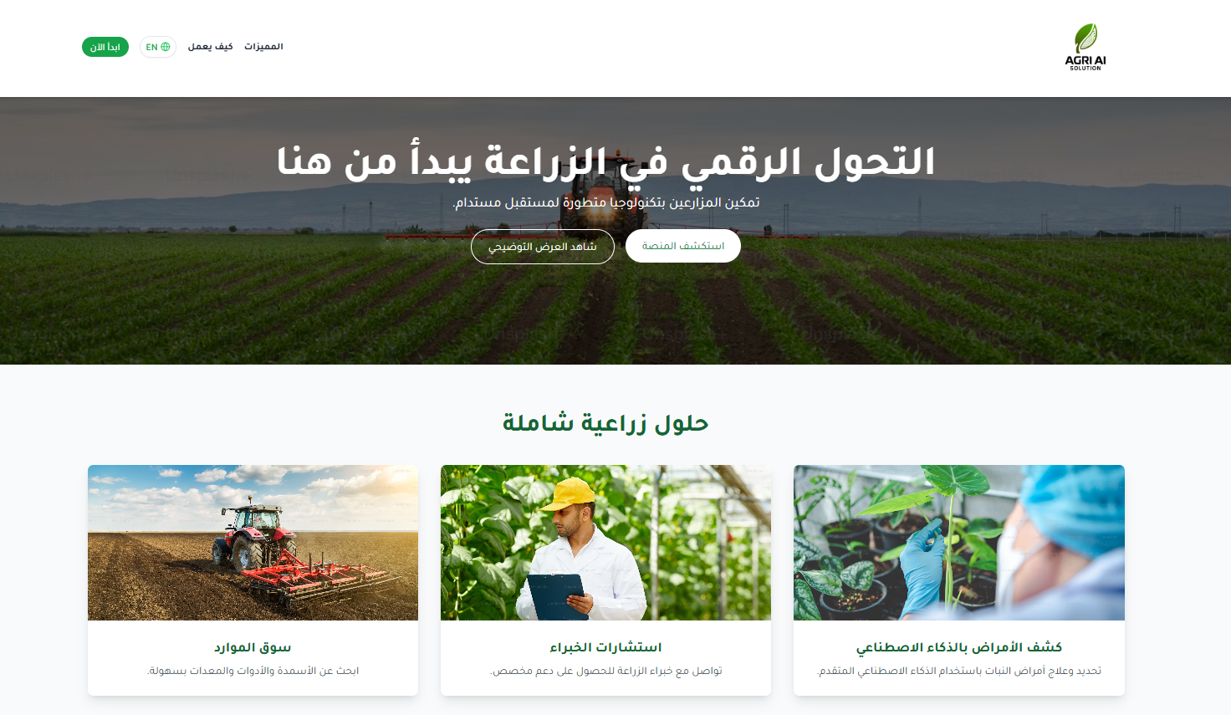

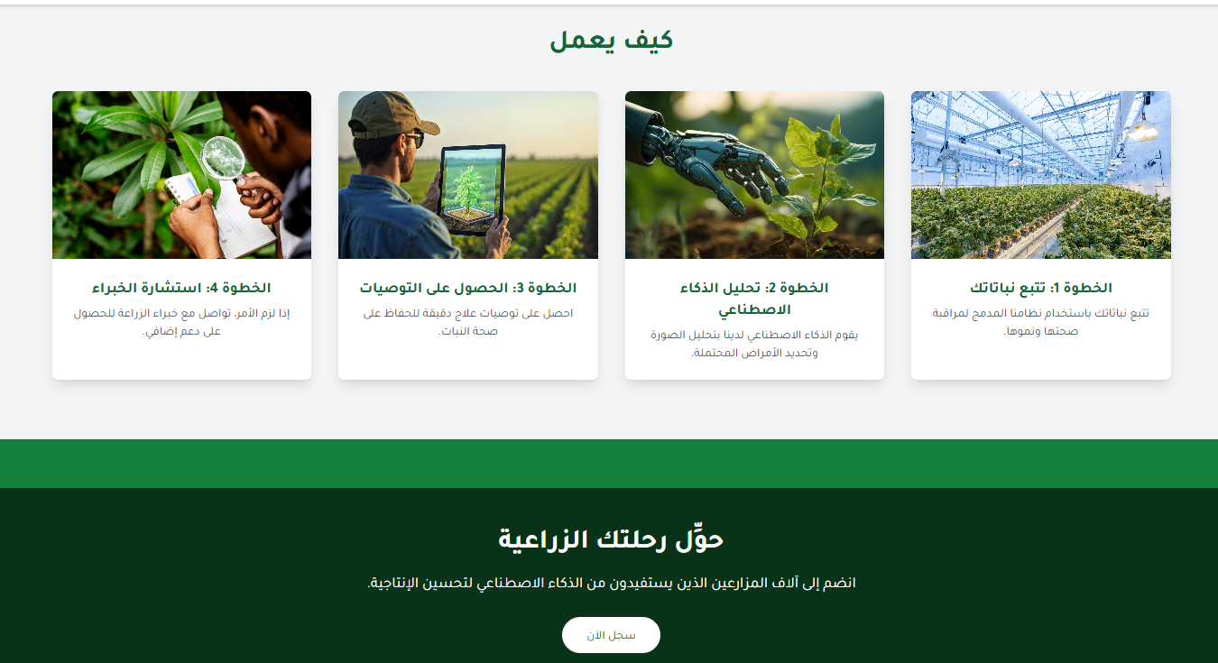

**Figure 5.6: Landing Page Design**

**5.1.6 Chat page:**

The **Chat Page** allows Communication between Farmers and Experts

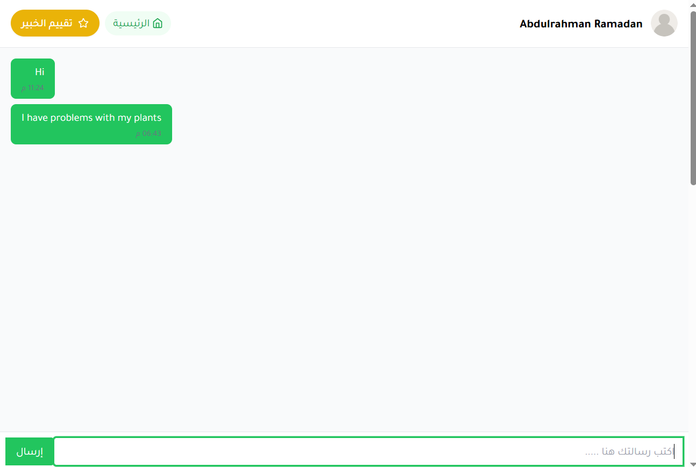

**Figure 5.7: Chat page Design**

**5.1.7** **plant analysis Result design:**

This page provides the output of Agri AI's AI-based plant diagnosis system after a farmer uploads a photo of a diseased plant.

**Main Components:**

**Plant Image Preview:** Clearly displays the uploaded image of the plant (e.g., an apple leaf with visible dark fungal spots). Helps the user visually confirm that the correct image was analyzed.

Diagnosis Summary - Analyzed Plant name - Detected Condition -Severity Level - Description: A short explanation of the disease -Treatment Plan (AI-generated Recommendations)

**Footer Info:**

Timestamp of analysis to track history.

**Purpose & Impact:**

This interface helps farmers quickly understand the issue affecting their crops and take immediate action.

The use of clear status indicators (condition, severity, and suggestions) ensures usability even for users with limited technical background.

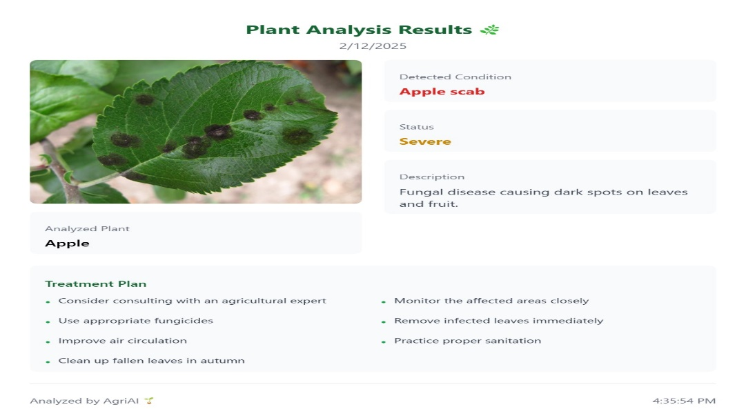

**Figure 5.8: plant analysis Result design**

**5.2 Artificial Intelligence**

**Enhancing Smart Agricultural Diagnosis**

**1. Understanding Agricultural Experts’ Methodologies**

**a. Data Collection:** The AI system starts by gathering agricultural knowledge from expert consultations, diagnostic cases, treatment records, guides, and field reports.

**b. Pattern Recognition:** Using machine learning, the system analyzes expert behavior—identifying diagnostic logic, treatment preferences, communication style, and focus areas.

**c. Agricultural Focus Areas:** The model identifies core goals emphasized by experts, such as:

* Diagnosing plant diseases
* Crop optimization and yield enhancement

**2. Smart Recommendations & Question Generation**

**a. Intelligent Diagnosis:** When a farmer uploads an image or describes an issue, the AI generates a preliminary diagnosis and recommends treatments based on expert-like reasoning.

**b. Complexity Adaptation:** Recommendations range from basic instructions for small-scale farmers to in-depth analysis for commercial operations.

**c. Continual Learning:** The model evolves by integrating new expert inputs, updated agricultural guides, seasonal trends, and farmer feedback.

**3. Farmer Interaction & Submission Handling**

**a. Interactive Platform:** Farmers can upload plant images, describe issues, or request help via a user-friendly interface. All submissions are categorized and stored to enhance AI learning and accuracy over time.

**4. AI Evaluation & Expert Oversight**

**a. Submission Analysis:** The AI uses image processing and NLP to analyze farmer input, detect agricultural problems, and suggest relevant solutions.

**b. Case Matching:** It compares new cases with previously approved expert cases, ensuring recommendations follow best agricultural practices:

* Visual symptom matching (e.g., spots, wilting)
* Context awareness (e.g., region, season)
* Structured responses (e.g., treatment + prevention)

**c. Expert Review Loop:** Experts can review, approve, or revise AI-generated responses, improving trust and diagnostic reliability.

**5.2.1 Feedback & Knowledge Assessment:**

**a. Smart Consultation Feedback Loop:** The system learns from ongoing interactions, improving the accuracy of its responses and offering tailored suggestions to boost crop health and productivity.

**b. Question Generation & Farmer Evaluation:** The AI can generate adaptive quizzes and knowledge tests on topics like pest control, disease diagnosis, and sustainable farming, aligned with local needs and varying difficulty levels.

**c. Performance Monitoring:** Farmer performance is tracked over time through diagnostic test results and system interactions, helping identify knowledge gaps and guide improvement.

**6. System Lifecycle & Continuous Learning**

**a. Real-Time Data Integration:** The system constantly updates its model using new field data, sensor readings, expert feedback, and farmer submissions to provide real-time, location-aware advice.

**b. Expert Collaboration:** Farmers can connect with human experts when advanced assistance is needed. Experts benefit from AI-generated drafts to accelerate their response time.

**c. Performance Reports:** The system delivers insights into common farmer errors and improvement suggestions, guiding better practices and increasing agricultural output.

**5.2.2 Advantages of Agri AI’s Smart System:**

* **Sustainability:** Equal access to expert-level knowledge fosters sustainable farming practices.
* **Flexibility:** Tailored solutions for each farmer based on local conditions.
* **Data-Driven Innovation:** Real-time analysis supports timely, climate-aware recommendations.

**5.2.3 Building the AI Model for Agri AI Solutions:**

**1. AI Model Development**

* Build a deep learning model to assist experts with disease diagnosis, soil analysis, and treatment suggestions using real-time sensor data, images, and expert knowledge.

**2. Accuracy Testing & Feedback Loop**

* Continuously evaluate model accuracy by comparing predictions to expert outcomes.
* Integrate real-time feedback from users to improve system performance.

**3. Iterative Training with Real Data**

* Train the model using real images, soil readings, and climate data.
* Leverage expert annotations and interaction logs for supervised refinement.

**Two Core Modeling Approaches**

* **Pattern Discovery:** Learn visual and sensor-based patterns to predict diseases and suggest interventions.
* **Data Summarization:** Analyze and condense complex input data to deliver easy-to-understand insights for farmers.

**5.3 Model Training & Deployment Pipeline**

**Training Phase**

* **Configuration:** Set key hyperparameters (learning rate, batch size, epochs).
* **Loss Function:** Use cross-entropy for classification tasks.
* **Training Loop:** Input preprocessed agricultural data (images, sensors, expert feedback) and iteratively minimize loss to improve accuracy.

**Evaluation Phase**

* **Metrics:** Evaluate using precision, recall, and accuracy.
* **Validation:** Test generalization on unseen data.
* **Model Saving:** Save the trained model for deployment in real-time systems.

**Deployment Phase**

* **Plant Disease Detection:** Diagnose diseases using ESP32-CAM images and sensor data. Provide actionable treatment plans and preventive measures.
* **Agricultural Recommendations:** Analyze soil salinity, weather conditions, and plant status to suggest optimized irrigation, fertilization, and crop rotation strategies.

**Chapter 6**

**Conclusions & Future Work**

**6.1 Conclusion**

The **Agri AI Solutions** project has successfully demonstrated the transformative potential of integrating Artificial Intelligence (AI) and Embedded System in modern agriculture. Through the development of a smart system that combines machine learning, real-time data analysis, and embedded hardware, the project offers practical, scalable solutions to some of the most pressing challenges in the agricultural sector.

**Key Achievements and Findings:**

* **AI-Powered Plant Disease Diagnosis**:

The system accurately identified plant diseases using advanced image recognition and pattern analysis techniques. This enables early detection, reduces the need for harmful chemicals, and minimizes crop loss—supporting more sustainable and efficient farming.

* **Cost-Effective and Eco-Friendly Practices**:

By automating tasks traditionally dependent on expert consultation, Agri AI reduces operational costs while promoting sustainable practices

* **Enhanced Farmer Productivity and Decision-Making**:

Timely, tailored recommendations help farmers increase yield and efficiency. The platform's data-centric approach enhances planning, crop rotation, and resource allocation.

* **Modular, Scalable, and Adaptable Architecture**:

The system’s modular design allows for seamless scalability—from smallholder farms to large-scale agricultural operations—making it suitable across diverse geographic and climatic conditions.

* **Collaborative Intelligence with Agricultural Experts**:

The involvement of local experts ensures that AI-generated advice is grounded in scientific accuracy and local best practices, enhancing both the relevance and trustworthiness of the system.

* **User-Friendly Design**: Prioritizing accessibility, the system features a clean, intuitive interface designed to accommodate users with limited technical experience. This facilitates broad adoption, particularly in rural and underserved communities.
* **Pioneering Innovation in AgTech**: Agri AI exemplifies how cutting-edge technologies like AI and Embedded system can revolutionize farming—automating workflows, enhancing productivity, and supporting sustainable agriculture at scale.
* **Proven Real-World Applicability**: The system has shown strong performance in real-life scenarios, supporting both farmers and agricultural consultants through practical, on-the-ground usage.
* **Supporting Global Sustainability Goals**: By promoting resource-efficient practices and reducing environmental impact, Agri AI contributes to global efforts in sustainable agriculture, food security, and climate resilience.

**6.2 Future Work**

To further enhance the impact and applicability of Agri AI Solutions, several areas have been identified for ongoing development and research:

**1. Model Expansion and Continual Learning**

* **Broader Disease Coverage:** Expand the plant disease database to include a wider range of crops and region-specific diseases, enhancing diagnostic capabilities.
* **Adaptive Learning:** Implement continuous learning pipelines that allow the AI to evolve through real-time farmer feedback and expert inputs, improving prediction accuracy over time.

**2. Advanced Sensor Integration**

* **Diverse Sensor Inputs:** Incorporate additional sensors (e.g., pH level, light intensity, CO₂ levels) for a more comprehensive environmental analysis, enabling finer-grained decision-making.

**3. Mobile App Enhancement**

* **Extended Features:** Add capabilities such as smart irrigation control, pest tracking systems, weather-based alerts, and voice-based interaction to further empower users.
* **Offline Mode:** Enable offline functionality to support rural areas with limited internet access.

**4. Localization and Language Support**

* **Multi-Language Platform:** Translate the interface into local languages to make the system accessible to farmers globally, including non-English-speaking communities.

**5. Strengthening Expert Collaboration**

* **Expert Feedback Loops:** Establish mechanisms for real-time expert review and feedback to continually refine the system’s recommendations and uphold agricultural accuracy.

**6. Scalability and Cloud Integration**

* **Global Deployment Models:** Explore cloud-based deployment for scalability, remote updates, and wider accessibility across developing and developed regions alike.

**7. Predictive and Advanced Analytics**

* **Insightful Forecasting:** Integrate predictive analytics to estimate crop yields, detect early risk of outbreaks, and model long-term farm performance using historical data and AI.

**8. Educational Integration**

* **Automated Grading & Feedback:** Enhance the educational component by integrating AI for auto-generating exam questions, grading student responses objectively, and providing constructive feedback—especially useful for training young farmers or agricultural students.

**References**

**Software Engineering**

• Sommerville, I. (2015). *Software Engineering* (10th ed.). Pearson Education.

• Pressman, R. S. (2014). *Software Engineering: A Practitioner’s Approach* (8th ed.). McGraw-Hill.

• <https://relevant.software/blog/agile-software-development-lifecycle-phases-explained>

**Back-End**

* Cantelon, M., Harter, M., Holowaychuk, T., & Rajlich, N. (2017). *Node.js in Action* (2nd ed.). Manning Publications.
* Ferdinandi, C. *Modern JavaScript for Beginners*.
* <https://nodejs.org/en/docs>
* <https://nodejs.org/api>
* <https://nodejs.org/en/docs/guides>
* <https://developer.mozilla.org/en-US/docs/Web/JavaScript>
* <https://nodejs.dev>

**Front-End**

* Banks, A., & Porcello, E. (2020). *Learning React* (2nd ed.). O’Reilly Media.
* Ferdinandi, C. *Modern JavaScript for Beginners*.
* <https://react.dev>
* <https://create-react-app.dev>
* <https://vitejs.dev>
* <https://fullstackopen.com>
* <https://developer.mozilla.org/en-US/docs/Learn/Tools_and_testing/Clientside_JavaScript_frameworks/React_getting_started>
* <https://www.freecodecamp.org/learn>

**Artificial Intelligence (AI)**

* Géron, A. (2019). *Hands-On Machine Learning with Scikit-Learn, Keras, and TensorFlow* (2nd ed.). O’Reilly Media.
* <https://platform.openai.com/docs>
* <https://huggingface.co/docs/api-inference>
* <https://www.tensorflow.org/js>
* <https://brain.js.org>
* <https://www.freecodecamp.org/news/tag/artificial-intelligence>
* <https://developer.mozilla.org/en-US/docs/Web/API>
* <https://x.ai/developers>

**Embedded Systems**

* Zhu, Y. *Embedded Systems with ARM Cortex-M Microcontrollers*.
* <https://docs.espressif.com/projects/esp-idf/en/latest/esp32/>
* <https://www.arduino.cc/en/Guide/>
* <https://www.tensorflow.org/lite/microcontrollers>
* <https://mqtt.org/>
* <https://docs.opencv.org/>

**React Native**

* Bierman, B. (2020). *React Native in Action*. Manning Publications.
* <https://reactnative.dev/docs>
* <https://reactnavigation.org/docs/getting-started>
* <https://docs.expo.dev>
* <https://callstack.github.io/react-native-paper/>
* <https://github.com/jondot/awesome-react-native>
* <https://www.freecodecamp.org/learn>